# CS 255 System Design Document Pieri

## UML Diagrams

### UML Use Case Diagram

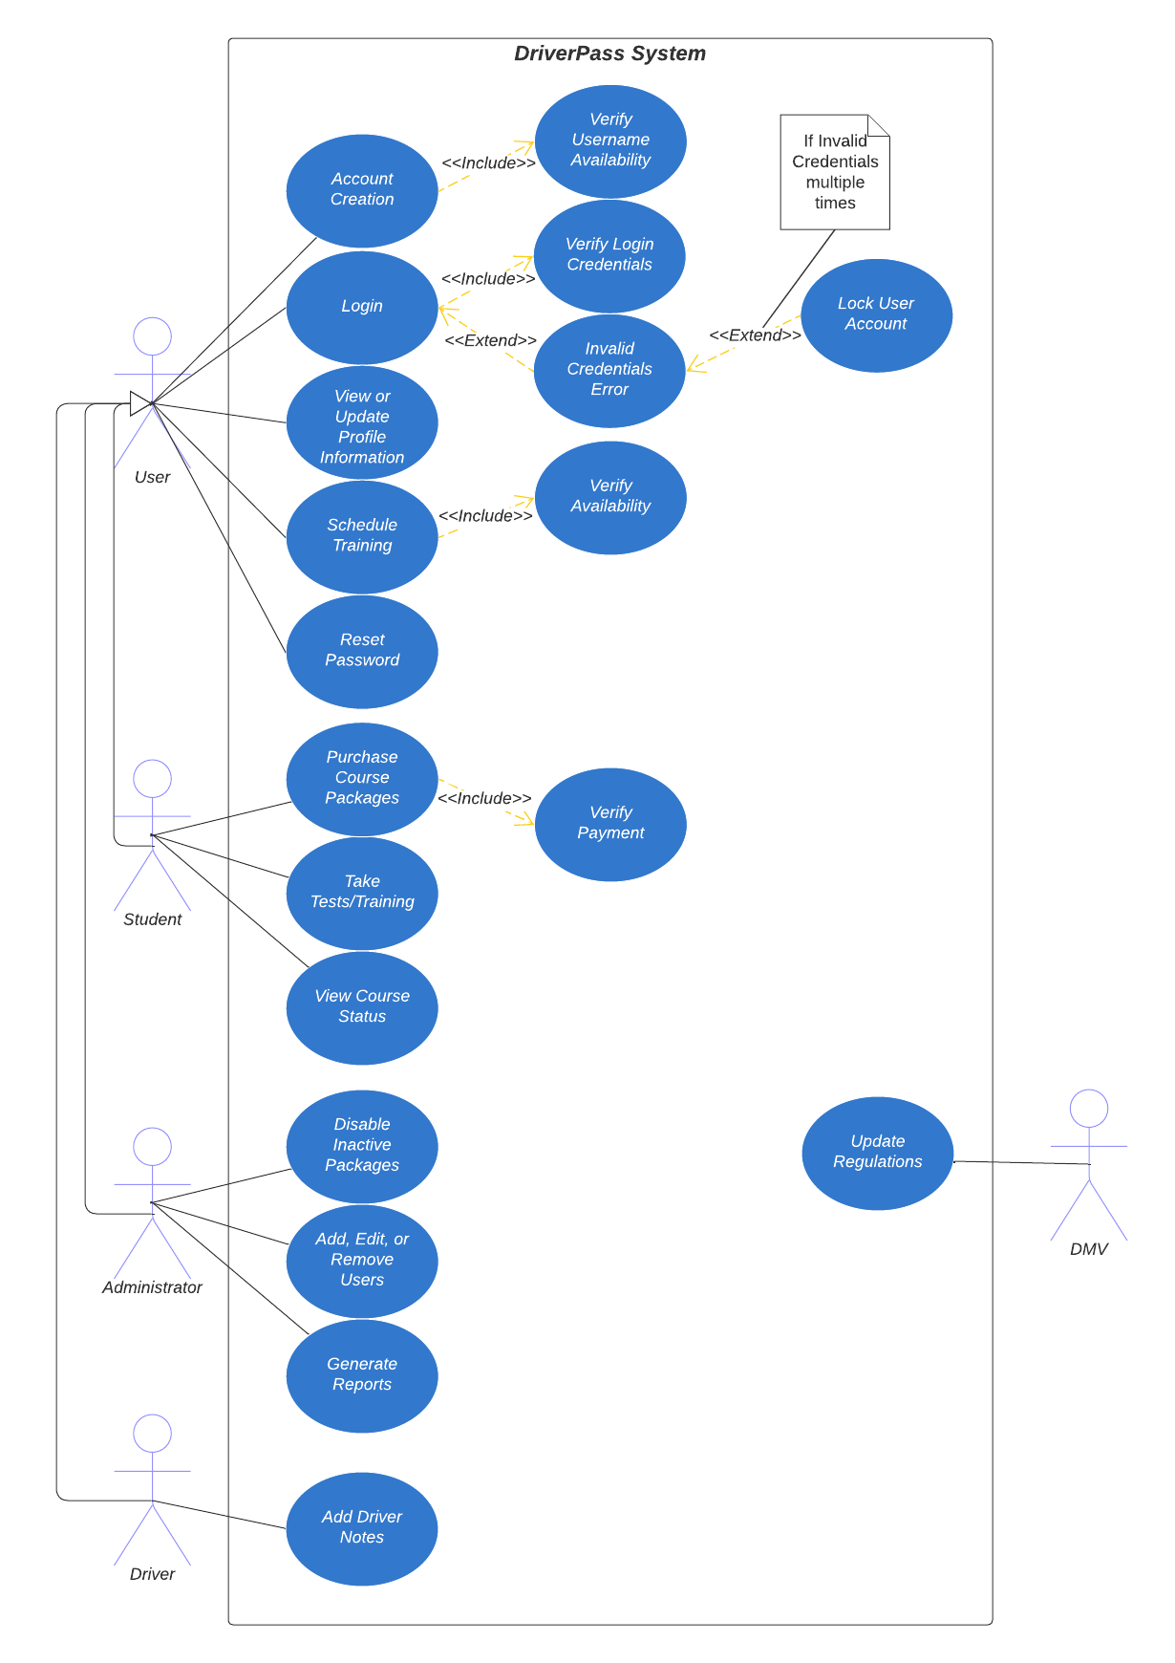

### UML Activity Diagrams (TWO)

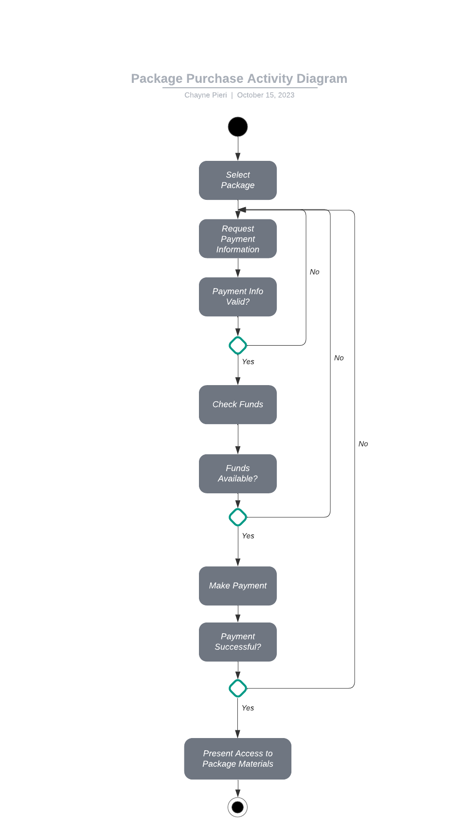

### UML Sequence Diagram

### UML Class Diagram

## Technical Requirements

Cloud Server Requirements:

* DriverPass Database uploads
* DriverPass Software updates
* Access to Cloud Service Provider (AWS, Azure, etc.)

Client Requirements:

* Device with Internet Access
* Updated Web Browser
* Updated Operating System (Windows, Linux, MacOS, Android, iOS)
* Device Power
* Internet Service Provider

Development Tools:

* Computer with Updated Operating System (Windows, Linus, MacOS)
* Programming software (Eclipse, Visual Studio, etc.)
* Access to Cloud Service to update database and software applications.
* Internet Service Provider
* Network Administration tools for Company Devices